Lambda Alpha International
Fall 2013, Land Economics Weekend - San Francisco

San Francisco was the host city for Lambda Alpha International’s fall 2013 Land Economics Weekend. The city’s famous fog was absent as LAI members were welcomed to a weekend of warm Indian summer weather. The focus of this trip would be two defining attributes of San Francisco; its booming innovation economy and iconic waterfront. Over the course of three days that included walking tours of development projects, panel discussions, a series of TED talk style lectures, and a ferry tour around the Bay, themes emerged of a city that cared deeply for sustainability and place making that has been built through strong public-private partnerships.
Friday, October 4th
Morning Panel Discussions
On Friday morning LAI members gathered at the SPUR Urban Center for breakfast and to hear panel discussions on San Francisco’s unique economic framework and city culture. SPUR is a local member-based nonprofit urban planning and policy think tank. With a history of over 100 years in the Bay Area and centrally located in the SOMA neighborhood next to the main city artery of Market street, the SPUR Urban Center served as an ideal backdrop to the weekend’s activities.
Work and Economy Panel
The first section entitled, “The Work and Economy Panel” was moderated by Jim Wunderman, CEO of the Bay Area Council and included presentations from Michael Covarrubias, CEO of TMG Partners, Ted Egan, San Francisco’s chief economist, Jim Gollub, director of Jim Gollub Associates, and Julie Sammons, a thought leader on nature-inspired design.
Opening Presentation: Jim Wunderman, CEO of the Bay Area Council
The Bay Area Council is a leading advocacy group for regional businesses. Wunderman’s presentation, “The Innovation Economy”, explained why the Bay Area is such a powerful innovation generator and how it can stay resilient to future market fluctuations. According to Wunderman, regional high value activity areas are the foundation of the innovation economy. These include local universities, San Francisco’s finance sector, and the Peninsula’s biotech, consulting and computer design facilities. Innovation is supported by what Wunderman referred to as, “the open source culture”, a collaborative work culture that allows information streams to flow freely across industries. Another important aspect of the regional economy is its strong global ties. These are used for importing both talent and technology from where the Bay Area has made overseas investments. There consequences for strong regional growth. Wunderman ended his presentation with a warning that the housing market and transportation infrastructure have been stressed by the recent growth. Investments in both areas are needed for region to continue to grow.
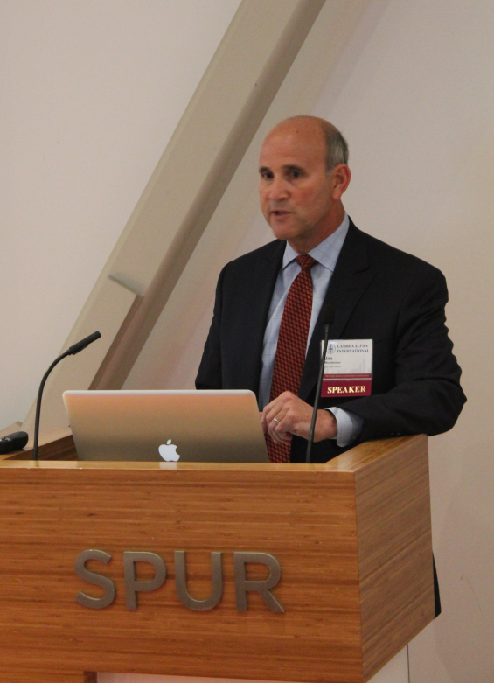
Jim Wunderman, Bay Area Council
Michael Covarrubias, President of TMG
The next speaker, Michael Covarrubias, is a local housing developer. He talked about his company’s strategies for meeting workplace demands of San Francisco’s new, young, tech-focused workers. According to Covarrubias, successful urban workspace for San Francisco can be reduced to 5 factors: walkability, proximity to transit, creative and collaborative workspace, proximity to gyms and an interesting aesthetic – such as the brick and timber that are so sought after in New York and Boston.
Julie Sammons, Director of the Bay Area Biomimicry Network
The panel then took a look toward the future to examine how today’s technology innovations can shape tomorrow’s “Smart Cities”. Julie Sammons, the founding Director of The Bay Area Biomimicry Network and an expert in “emergent” technologies, educated LAI members on the potential of micro-manufacturing – building technologies from the nanoscale up. Such innovations could make urban environments much more interactive and responsive to its occupants. Sammons described an example of sensors that coat buildings -- monitoring and adjusting climate, air quality and lighting without direct human assistance. Such technologies will bridge the gap between people and the built environment, making us much more embedded in the cities and neighborhoods we live in. The type of environment where these technologies are being developed is what Sammons described as, “hacker garages” - low-rent, community-driven work spaces that foster collaboration and can bring together enthusiasts from many different fields.
Jim Gollub, Director at Jim Gollub Associates LLC
A self-described, “Economic Therapist”, Gollob explained how his company helps innovation centers capitalize on discoveries and find their marketplaces. This involves a three step process to mobilize stakeholders, analyze findings and catalyze them into action. Innovations centers include universities, business parks, and research and development facilities.
Ted Egan, San Francisco’s Chief Economist
Egan provided the numbers behind San Francisco’s growing economy and how it compares both regionally and nationally. Jobs in San Francisco have surpassed pre-recession levels and San Francisco county has the fastest job growth in the country. This resurgence is led by the booming information sector, but every sector of the City’s economy is outpacing the US growth rate. The hotel industry has also recovered. Well. Average revenue per available hotel room has risen steadily and is now 120% of the pre-Recession high. San Francisco leads the nation in home value and is fifth in home appreciation. Despite this growth, San Francisco has experienced little wage inflation since 2007.
City Culture Panel
The second panel discussion entitled, “The City Culture Panel”, was moderated by SPUR’s executive director, Gabriel Metcalf. To begin, Metcalf painted a portrait of San Francisco as a city on a meteoric rise to economic prominence, yet struggling to cope with the population growth that this economic resurgence has brought.
Opening Presentation: Gabe Metcalf, SPUR Executive Director
San Francisco is experiencing an unprecedented job growth. What is fueling it and what will this growth mean for the city? Metcalf addressed these questions in his opening presentation. Cities, especially San Francisco, have become incubators for collaboration. The resulting demand for office and housing space has led to a construction boom. Today there are 6,000 units under construction in the City. San Francisco now has the most expensive rental market in the county with an average price tag of $3,396 per month.
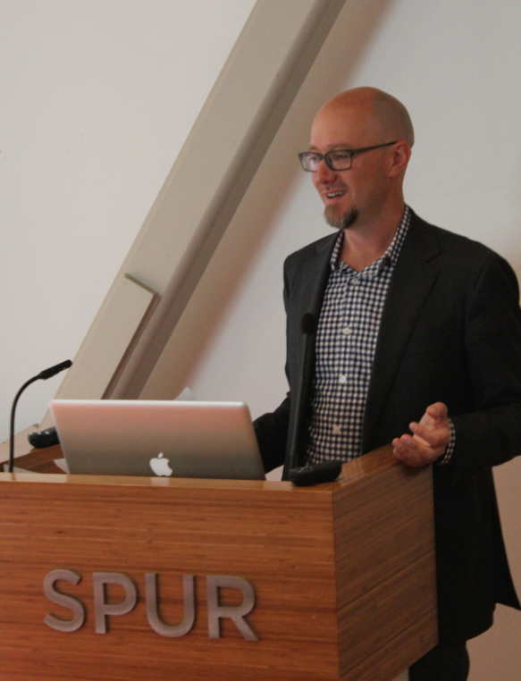
Gabe Metcalf, Executive Director of SPUR
Molly Turner, Public Policy Director at Airbnb
What is the “Sharing Economy” and how can it benefit us? Molly Turner explained how our individual assets; our home, car, expertise, and even our garden tools can be monetized, bringing more financial security to the seller, more options for consumers and knitting us closer together through shared dependency and interactions.
Patrick Kennedy, Owner of Panoramic Interests
Kennedy is a developer specializing in high density, in-fill sites. His presentation discussed how micro-unit housing can meet the needs of the San Francisco Bay Area’s changing demographics and culture. As Kennedy pointed out, fewer city dwellers are living in single family households. In San Francisco 41% of residents live alone and 56% are in non-family households. People living alone are the fastest growing demographic in San Francisco. The number of renters has also risen. Since 2006, the percentage of Americans who rent has grown steadily. In summary, San Francisco (and many cities) has a growing population of single occupancy renters who place a high value on close proximity to transit and work. There is a high demand for housing that puts a priority on functionality, location and inviting communal spaces. Micro-unit housing is a smart way to meet these demands. Kennedy’s firm determined an ideal micro-unit apartment size of 300 square feet. These smaller apartments translate to higher density developments. For example, Panoramic Interest’s micro-unit apartment building at 1321 Mission Street has three times the density of a conventional apartment building.

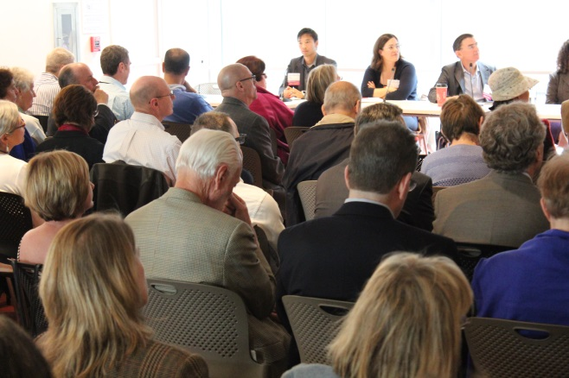
LAI members at the City Culture Panel
Laura Crescimano, Principal at SITELAB Urban Studio
By comparing workplaces to the ubiquitous coffee shops of San Francisco, Cresimano showed how the modern day offices are changing to reflect a work culture that values collaboration, socialization and a limited hierarchy. Therefore, workspaces are becoming more open, flexible and social - much like a coffee shop.
Paul Supaqanich, Transit Planner with Nelson/Nygaard Consulting Associates
As a local transit expert, Supaqanich spoke about how San Francisco can make transportation work better for its residents. One key concept was how to replace car ownership with access to different forms of transportation. Carshare programs like Zipcar and City Carshare and taxi services like Lyft and Uber are giving residents reliable access to cars. Combined with light rail, buses and BART, these car startups have allowed city residents to forego car ownership. Another important concept for planning city transportation is the quality of a rider’s commute time. Public transit (when done well) can make the time spent commuting much more valuable and productive to riders.
Lunch in Yerba Buena Park
After two compelling panel discussions on local economy and culture, LAI members partook in the more simple pleasures of lunching in Yerba Buena Gardens, one of the City’s most cherished and celebrated parks. Situated a block away from the SPUR Urban Center and surrounded by noted museums like the SFMOMA, Jewish Contemporary Museum and the Yerba Buena Center for the Arts, the park was the final piece of the Yerba Buena Redevelopment Area. Since its creation in 1993 the park has won numerous awards both for its multi-use design and the inclusiveness of the project’s development process. It is now managed by the San Francisco Redevelopment Agency.
Walking tour of 5M
After lunch the group walked down Mission Street to the San Francisco Chronicle Building for a tour of Forest City Enterprises’ 5M project. The project is a mix-used development. Its first implementation is the retrofitted lower levels of the Chronicle Building that have been converted into a mosaic of open floor plan workspaces. By 2026, the year the project is scheduled to be completed; it will encompass 1.85 million square feet over a 4 acre site that includes 1 million square feet of office space, 750 new dwelling units, and 150,000 square feet of ground floor retail, educational and cultural uses. With such numbers the 5M project is a main reason the Mid-Market neighborhood is the most popular place for new development in San Francisco.
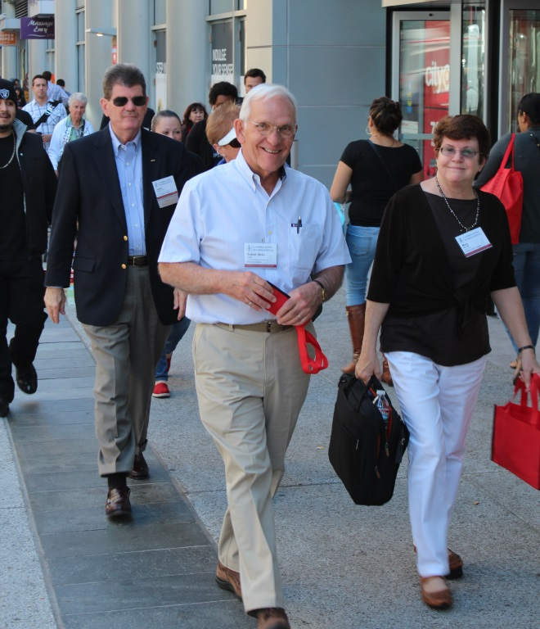
Walking to the 5M Project
Alexa Arena, Senior Vice-President of Forest City and manager of the 5M Project, met LAI members at the Chronicle Building to lead a walkthrough and introduce them to the tenant companies. These included: The Hub, a membership based office space; Square, an online payment company; Off the Grid, an organization that plans and manages street food events throughout the Bay Area; and Intersection for the Arts, a nonprofit that uses art as a method to provide structure and direction to inner-city youth. Arena emphasized that this group of tenants was not happenstance, but a carefully selected cohort of like-minded businesses that could benefit from the building’s design. The open floor plan, ambiguous delineations between tenant spaces and many communal areas were made to stimulate interaction and exchange among occupants. The 5M Project appeared to be a physical manifestation of the “open source community” Jim Wunderman spoke about during the morning’s discussion.
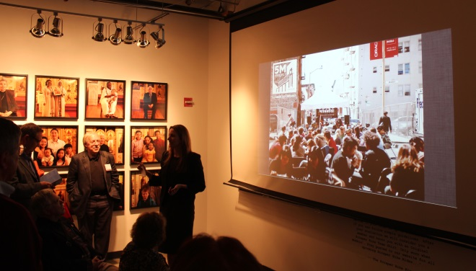
Alexa Arena talking about the 5M Project
Eventually Tim Nichels, the Director for The Hub, joined the tour and LAI members were curious to know how much a Hub business membership costs. Monthly rates start at $35, but rental structure is flexible. It’s possible to rent a space for a day, week or year. 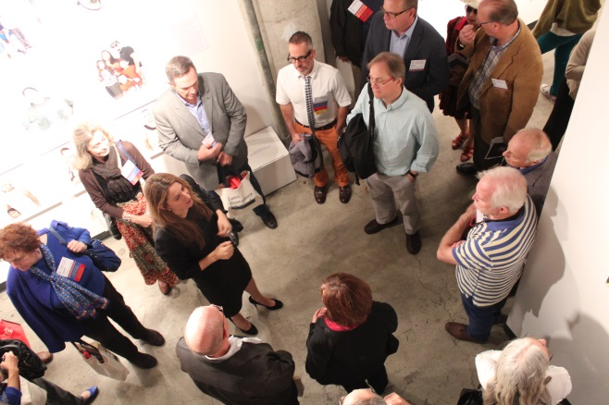
Alexa Arena leading 5M site tour

The tour continued to the TechShop, an open access public workshop located a block from the Chronicle building. Based in Menlo Park, the Techshop has workspaces in cities across the country. Inside LAI members were given a glimpse of the sophisticated technologies the TechShop provides such as laser cutters and 3D printers. Local innovators and entrepreneurs make up the membership base here. The workshop provides an opportunity for developers to prototype and fine-tune designs before their work has attracted investors. The model seems to be working. Two weeks before LAI member’s tour, the TechShop announced plans to raise $60 million for expansion to Los Angeles, Boston, Baltimore, and New York among other cities.
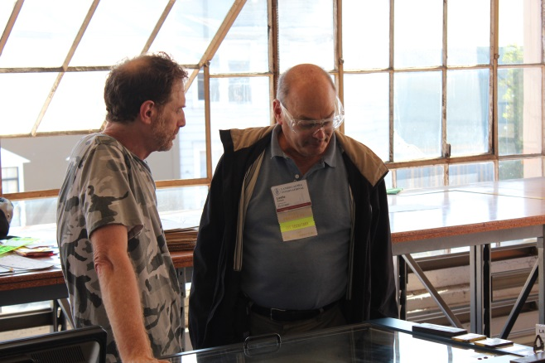

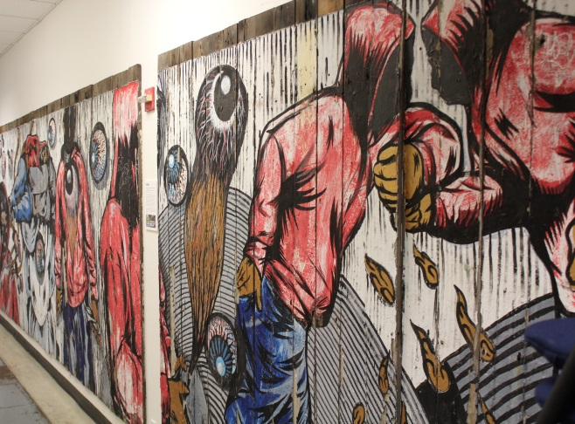
Hallway mural, 5M Project
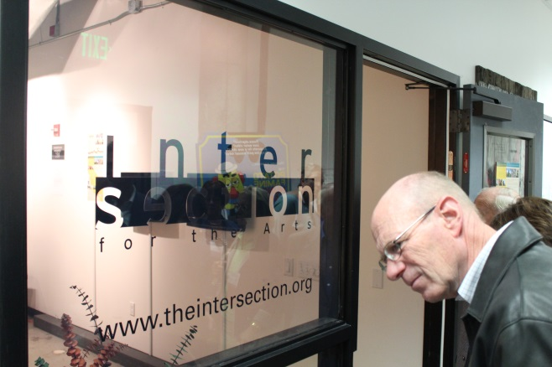
Intersection for the Arts offices, 5M Project
The Mission Bay Tour
Upon boarding their buses LAI members were met by Catherine Reilly, Project Manager for the Mission Bay Redevelopment Area. Reilly works with the City’s Office of Community Investment and Infrastructure and she oversees the development of the 303-acre Mission Bay area. During the short bus trip to the project site the group drove through the area included in the City’s Central SOMA Plan. This project will build on the substantial transit investment in the area, including the $1.6 billion Central Subway project, as well as existing infrastructure from Caltrain and Muni to create concentrated housing and business development. The plan is largely funded by a transportation planning grant from Caltrans.
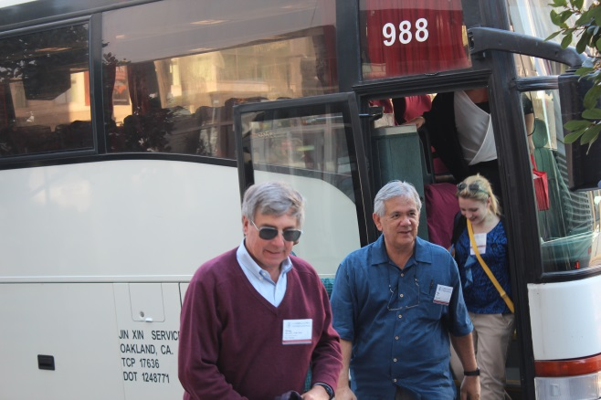LAI members arrive in Mission Bay
As the buses headed toward their destination, Reilly recounted interesting figures from her project. Mission Bay required $700 million in infrastructure and, when finished, will include 30% low-income housing. The project is funding these costs with a tax increment financing strategy. When completed, Mission Bay will have 6,350 residential units, 4.4 million square feet of office/biotechnology space, a 43-acre research campus for the University of California, San Francisco (UCSF); 400,000 square feet of retail, and 49 acres of public parks.
The group disembarked their buses at Mission Bay Library to hear presentations from two of the project’s most knowledgeable individuals; Seth Hamalian, the Managing Principal of the Mission Bay Development Group LLC; and Amy Neches, a developer with over 17 working for city and served as the City’s negotiator for the Mission Bay redevelopment. Hamalian began the presentation by talking about initial stages of development. The following are interesting takeaways from the presentations:
- In order to speed up build out and limit individual, the project used many different developers for the north end of Mission Bay.
- Penalty fees for developers not building promptly also sped up construction. If not ready to build, developers were given the option to sell to a colleague who was.
- At full build out there will be $5.5 – 6 billion dollar tax-base. This is despite UCSF campus tax exempt status.
- The sewers and parks of Mission Bay are not maintained by the City’s general fund, but by a special tax.
- Public space for the project is set at 45% of what is allocated for private use.
- The affordable housing units do not pay for parks. A self-tax is administered to the developer to pay for these and other infrastructure costs.
- Currently there is a 95% occupancy rate for residential units and almost all units are condo mapped.

After the presentations LAI members were led outside for a walking tour of the Mission Bay site. A pedestrian bridge over Mission Creek brought the group into the project area. As Hamalian informed LAI members, houseboats in Mission Creek were the first dwellings in this area. The Port of San Francisco recently re-signed a master lease with house boats tenant through 2055.
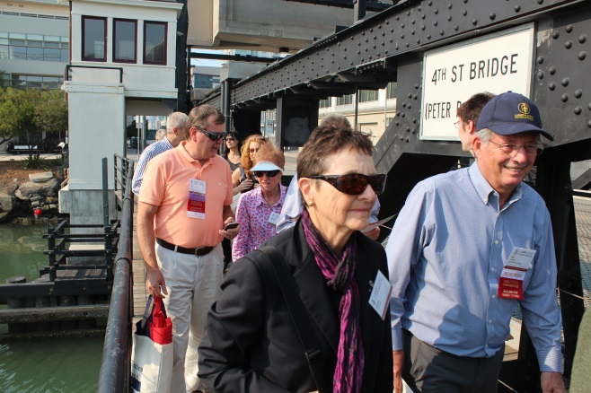
LAI members crossing the 4th Street Bridge into the Mission Bay Project site
The tour continued down 4th street through rows of beige and eggshell colored buildings into the core of project’s new development. When asked about the uniformity of design among the Mission Bay buildings, Neches mentioned that the height zoning of 63 feet, 90 feet, and 160 feet throughout the development area did not encourage variety. Projects that exceed one threshold would usually increase the height until it met the next one. The aesthetic similarities, he noted, may be due to the buildings being constructed in the same time period.

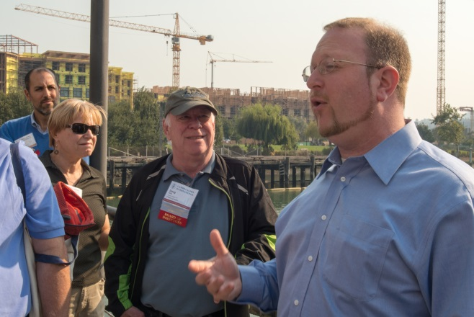
Seth Hamalian leading LAI members on the Mission Bay Project site tour. Photo by Elliot Lieberman
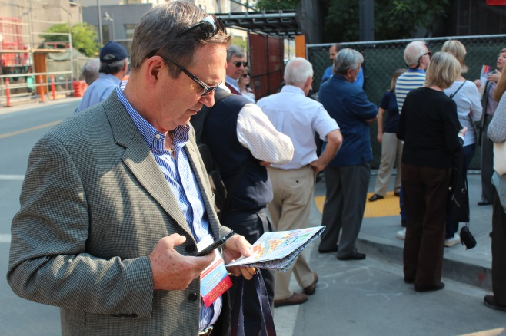
Mission Bay Project
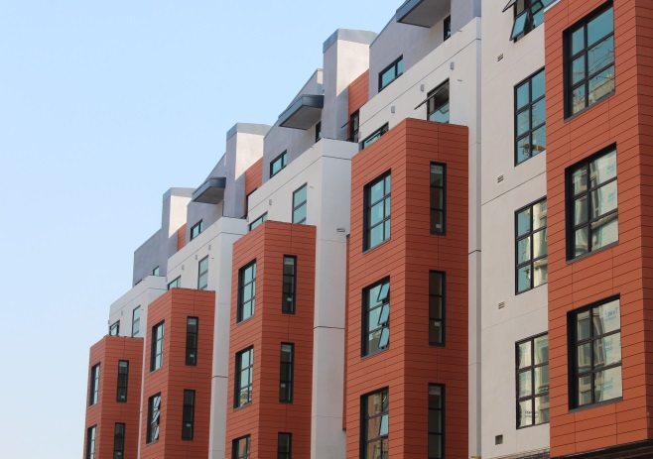
Apartments in the Mission Bay Project
Dine Around Town:
In the evening LAI members reconvened in the lobby of the Westin St. Francis located on San Francisco’s Union Square, popular plaza for retail named after the rallies for the Union Army that were held there during the American Civil War. From there, visiting LAI members traveled to a variety of pre-selected venues, each hosted by an LAI-Golden Gate member, including some of San Francisco’s finest restaurants, as well as a more intimate dining experience in the homes of some of the Chapter’s most distinguished members.

Saturday, October 5th
Morning Presentations
On Saturday morning, LAI members again gathered at the SPUR Urban Center, this time to hear a series of brief, TED-styled talks about San Francisco’s waterfront history. The first series of speakers included Charles Fraccia -- a celebrated historian and founder of the California Historical Society; Ben Grant – SPUR’s Urban Design Director and Manager of the Ocean Beach Master Plan, Michael Boland – the Director of Planning for the Presidio Trust, and Boris Dramov – a Principal with the Roma Design Group.
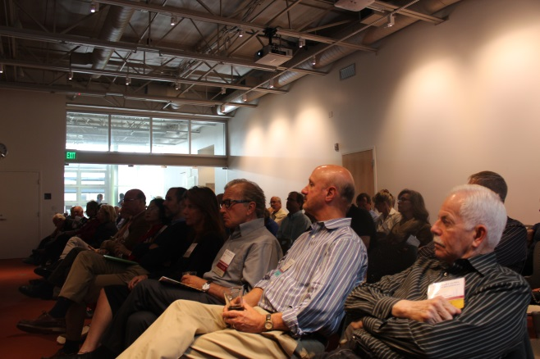
LAI members attending the Saturday morning TED-styled talks at the SPUR Urban Center
Charles Fraccia, Historian
San Francisco’s chief chronicler, Charles Fraccia, led the audience through a historical tour of the city’s waterfront. After Spain lost local control to the US in 1822 the Port of San Francisco began undergoing changes that would eventually make it the 2nd busiest port in the county. Yerba Buena Cove, first port of the city, was filled to expand San Francisco’s reach to Montgomery Street. This neighborhood became known as the Barbary Coast, after the infamous pirate-dominated coastline of Northern Africa, and was the red-light district of San Francisco. The height of the Port’s traffic was brought on by the California Gold Rush in 1948. Northern California was also developing into a major agricultural center at this time and was even the world’s largest wheat exporter. Eventually, intense disputes over ownership and litigation of the port lead the state of California to take control in 1863 with the establishment of the Board of State Harbor Commissioners.
The Transcontinental Railroad’s arrival in Oakland in 1869 ushered in the end of the Port of San Francisco’s prominence as a shipping site as ships preferred to go straight to the awaiting cargo trains at the Port of Oakland. Control of the port was returned to the City in 1968 with the creation of the San Francisco Port Authority to manage the waterfront for the citizens of California. The Port Authority receives no financial support from the City and instead relies on leases of Port property to generate revenue.
Ben Grant, Ocean Beach Project Manager
The next presentation shifted focus to San Francisco’s coastal shoreline and the site of the City’s first battle against sea-level rise -- Ocean Beach. Due to the many stakeholders and overlapping management agencies that control Ocean Beach, attempts to mitigate beach erosion are difficult. Ben Grant, Manager of the Ocean Beach Master Plan, illustrated this problem to LAI members with a list of over 12 different organization that are actively involved in the Ocean Beach planning process. These include: The California State Coast Conservancy, the City’s Public Utilities Commission, the National Park Service, the Army Corps of Engineers.
The area in question is San Francisco’s western coastline, spanning from Land’s End to Lake Merced. The beach is bordered by the Great American Highway and the Oceanside Water Treatment Plant on its southern end with the Lake Merced wastewater tunnel running underground adjacent to the highway. Previous attempts at protecting beach erosion had mostly been emergency, short-term strategies of protecting threatened areas with deposits of rock and gravel. Ben Grant proposed a long-term plan to LAI members that entailed removing parts of the highway to be replaced with a buffering zone of dunes and vegetation to absorb high water storm surges and a multimodal promenade that will enhance public access to the beach.
Michael Bolan, Planning Director of the Presidio Trust
The next presenter was Michael Bolan, chief planner of the Presidio Trust. He described the Presidio as, “a relic of natural systems that have been preserved and woven into the design of future development”. Used as an active military installation until 1989, the Presidio was transferred to the National Park Service in 1994. The park was created by a unique law that made it part of the Golden Gate National Recreation Area, yet turned management over to the Presidio Trust with the mandate that it must eventually pay for itself. Bolan was happy to declare that the park has recently become financially self-sufficient early this year. Revenue sources came, in part, from strong private-public partnership that rehabilitated and leased the Presidio’s buildings. The Trust estimates that over $1.2 billion in capital has been invested into the Presidio.
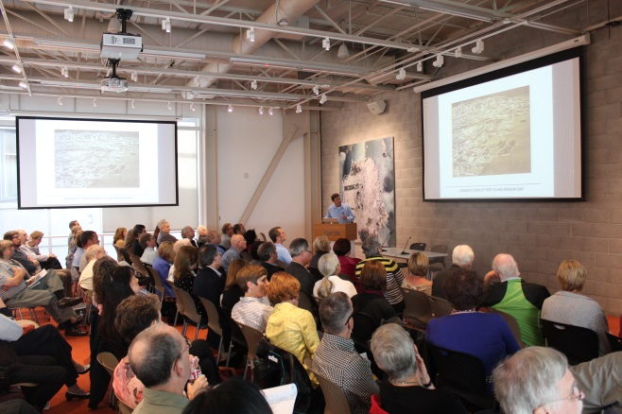
LAI members listen to one of the morning TED-style presentations
Today Bolan strives to honor the legacy of the park’s historical tenants – the US Army – by enhancing the park’s three principle public benefits; stewardship of nature, public accessibility, and educational impact. The Trust’s pledge of stewardship is demonstrated by the protection of the park’s undeveloped natural spaces and urban design intent to bring the natural environment into existing infrastructure. This also includes a public replanting of the Kobbe Forest within the park. The Presidio is host to numerous education programs including a series of camping nights for the city’s underserved youth. A new welcome center will eventually connect the Main Post of the Presidio to the Crissy Field waterfront. Construction will begin on a 10 acre parcel located on top of the new Presidio Parkway tunnel approach to the Golden Gate Bridge.
Boris Dramov, Principal of Roma Design Group
The next presentation by Roma Design Group Principal, Boris Dramov entitled, “The Embarcadero Story”, dealt with San Francisco’s tumultuous history of highway development and deconstruction along the waterfront. The Embarcadero is the name of both the City’s eastern waterfront and roadway that stretches from Mission Bay to San Francisco Aquatic Park. The Embarcadero Freeway was built in 1958. It was part of President Eisenhower’s plan to mobilize automobile transportation in cities. The freeway was intended to improve connections between the Bay Bridge and the Golden Gate Bridge, though its western span, the proposed Golden Gate Freeway, was never built.
The Embarcadero Freeway was a gloomy, two-tiered behemoth that separated the city from its own waterfront and blighted the surrounding area. The 1989 Loma Prieta earthquake critically damaged the freeway and gave critics of the freeway an opportunity to call for its removal. In 1991 the freeway was torn down and the city began to invest in revitalizing the area. The city rebuilt the Embarcadero as a tree-lined boulevard that blends alternative modes of transportation, including a pedestrian promenade, a bicycle corridor and a popular streetcar line that runs to tourist destinations like Pier 39 and Fisherman’s Wharf. The only reminders of the Embarcadero’s past are plaques in middle of road that mark the location where freeway columns once stood.
Cathy Simon, Design Principal with Perkins + Will
After a brief break LAI members returned another series of presentations about various development projects on the waterfront. Cathy Simon, a Design Principal with Perkins + Will began with a presentation on one of the waterfront’s most iconic structures – the Ferry Building. One of the few buildings to survive the great 1906 fire, the ferry building’s proximity to the waterfront allowed fireboats to protect it from the flames. Before the adjacent Bay Bridge was constructed, the Ferry Building was second largest transit center in the world, only surpassed by Queen’s station in London. In its heyday, the constant arrivals and departures of ferries from all corners of the Bay and the nexus of cable car lines spread out across the city helped define the Ferry Building as beating heart of the Bay Area and perhaps the most important structure in the city. Once the Bay Bridge was completed an ordinance was passed that limited ferry traffic within a 5 mile radius of the bridge and marked the end of the Ferry Building as a transit center. Since then there have been many ideas to re-imagine the Ferry Building.
In the 1950’s the building was adapted for office use and its public spaces were broken up. The building’s prominence was further diminished when it was walled off from the public by the construction of the Embarcadero Highway. The Ferry Building languished in obscurity until the 1989 earthquake when the damaged freeway was removed. The Port of San Francisco then mandated that reconstruction of the Ferry Building be used to draw San Franciscans back to the waterfront.
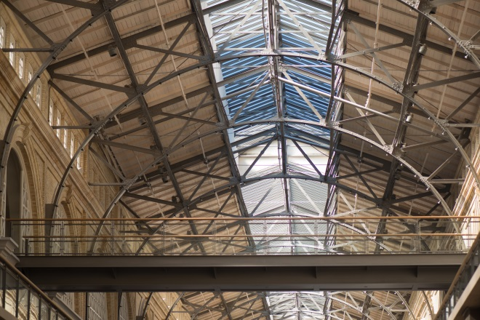
Renovated ceiling of the Ferry Building. Photo by Elliot Lieberman
Financing the rehabilitation of the Ferry Building was made possible by strong public-private cooperation and a long-term development and management model. Over 175,000 square feet of leasable Class A office space was created on the building’s upper two floors. The ground floor was reserved for public space and a marketplace for local culinary businesses. Its focus on local businesses has become a reflection of the values and aspirations of local residents, and the marketplace has successfully avoided the homogenous brand of vendors that plague other tourist destinations. The Port of San Francisco entered into a 67 year lease with Equity Office, a private investment firm which invested $110 million into the restoration. The project has been a financial success. The building has a 100 percent lease-up for both retail and office space, and is generating positive returns. The local business tenants and farmer’s market create a symbiotic relationship, each thriving off the others clientele. The farmer’s market is now the largest in the city, drawing upwards of 25,000 Saturday visitors.
Jennifer Matz, Director of Waterfront Development
The next presenter was Jennifer Matz, San Francisco’s Director of Waterfront Development. She discussed one of the waterfront’s most provocative development proposals – the prospect arena and new home of the Golden State Warriors. The proposed stadium would be located on piers 30 – 32. In addition to the excitement of bringing the Warriors basketball team back to San Francisco, the arena would provide the city with an amenity it currently lacks - an indoor venue space for 10,000 people. Since the piers are held in a public trust and cannot be sold development has historically been difficult. The Port can only offer a lease of up to 60 years. The projected annual economic benefit of development would be $280 million.
Kevin Conger, Treasure Island Development Project
The next project to be discussed was the Treasure Island Development Project. The project’s landscape architect, Kevin Conger, a founding partner of CMG Landscape Architecture, spoke to LAI members about the history of the Bay’s in-fill island and the vision for its future. Treasure Island was built in 1936 for San Francisco’s World’s Fair – the 1939 Golden Gate International Exposition. For its role in the World’s Fair, the island was registered as a California Historical Landmark and several of its buildings are listed on the National Register of Historic Places. With the onset of WWII, the island was converted into a military base and remained so until the late 1980’s.
Like the San Francisco waterfront, Treasure Island is held in a public trust making development difficult. To navigate this obstacle a trust exchange was created that adds land from the adjacent Yerba Buena Island into the trust and releases sections of Treasure Island to sell to private developers. Highlights of the project include; 8,000 residential homes, 420 hotel rooms, 235,000 square feet of retail and 300 acres of open space. The project design emphasizes walkability with mixed-use, compact development and a notably pedestrian street that leads to the proposed ferry terminal. The abundant open space afforded the project will be leveraged to create regional destination the Bay Area through a mix of sports fields, an urban agricultural park and wetlands.
Brad Benson, Project Manager for the Port of San Francisco
The next presentation bought LAI member back to the San Francisco waterfront. Brad Benson, Project manager for the Port of San Francisco discussed Forest City’s new development project on Pier 70. The appropriately named the Pier 70 project is a multi-use development that will have 2.2 million square feet of office space and as many as 1,000 housing units. There will also be 275,000 square feet for artisans, retailers, designers and boutique manufacturing. The project builds on ideas cultivated at Forest City’s 5M project. Housing, office space, and local businesses are set in close proximity to each other and among ample public open space.
The pier is also used for ship repair and is the largest floating dry dock on the U.S. West Coast. Phase one of the project will include the renovation of two historic shipyard buildings into housing units, one with a ground floor marketplace.
Lunch at the Ferry Building
After a morning of stimulating presentations, LAI members were given the opportunity to experience one of morning’s topics in person with a lunch at the Ferry Building’s acclaimed farmer’s market. Most LAI members opted to enjoy the warm weather and walk to their destination from the SPUR Urban Center. Those that did so passed by another prominent development in the city – the new Transbay Transit Center, a massive $4.5 billion dollar project that will serve as a modern regional transit hub by connecting 11 of the Bay Area’s transit systems.
In true San Francisco spirit, LAI members meandered and tasted their way through the bountiful variety of produce from farms across Northern California. Among the throngs of smart phone wielding techies, off duty construction workers, wide eyed tourists, and local artisans peddling their wares, it was easy see why Cathy Simons had referred to the Ferry Building as, “the living room of the City” in her presentation that morning.
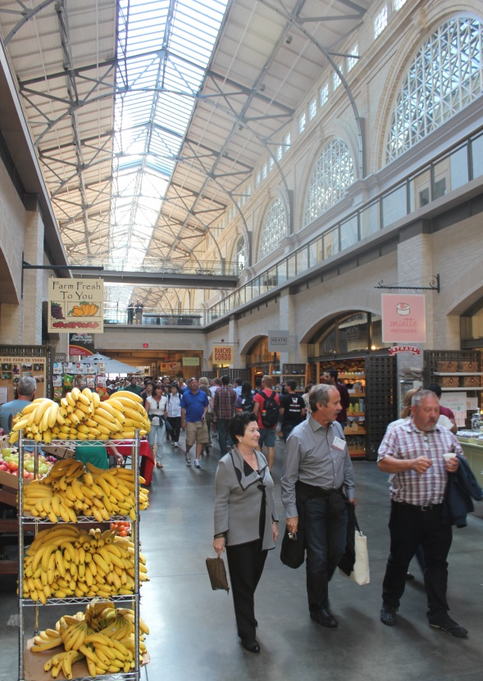
LAI members walking the Ferry Building’s food market
Ferry Tour of the Waterfront
After lunch LAI members were given the chance to see from the water projects they had spent the morning learning about. Boris Dramov, president of the Roma Design Group and a distinguished local architect was on board to provide commentary and point out notable sights.
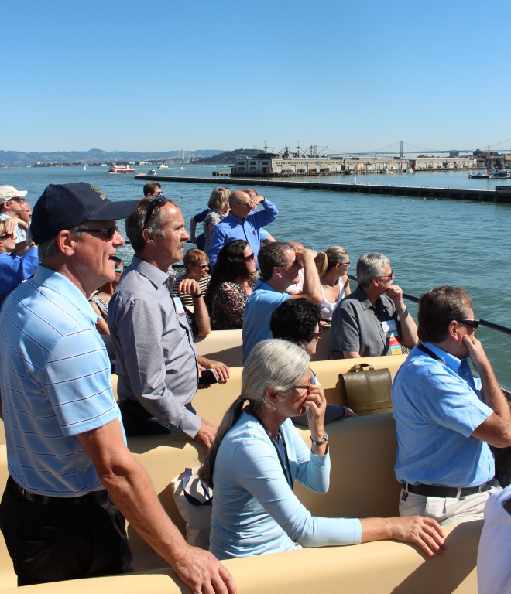

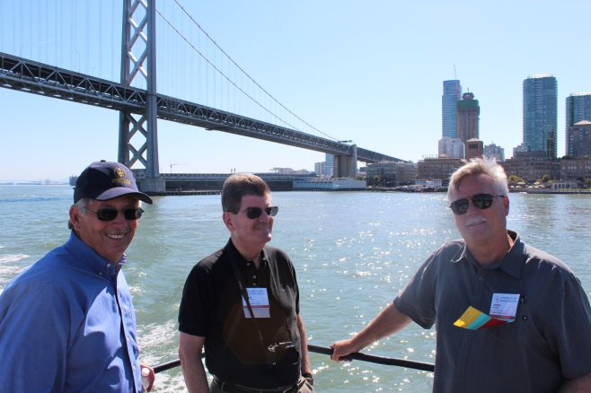
The ferry headed west along the waterfront giving LAI members clear views of Pier 7, the Exploratorium, the new cruise ship terminal and eventually the Aquatic Park, Crissy Field and the Presidio. The boat then circled underneath the Golden Gate Bridge before heading back into the Bay. Heading east back into the Bay, LAI members were taken past Alactraz Island before passing by Treasure Island and under the white suspension tower of the new eastern span of the Bay Bridge. This new section, connecting Treasure Island to Oakland, was opened to in October of this year and is currently the widest suspension bridge in the world. The reason being – Bay Area bike enthusiasts will happily declare – is the multi-modal path next to freeway that will soon allow people to bike and walk between Treasure Island and the East Bay.

As the ferry began its return to port it passed by China Basin and Mission Bay the group was treated to views of AT&T Park, and piers 30 – 3, the site of the proposed Warriors stadium.
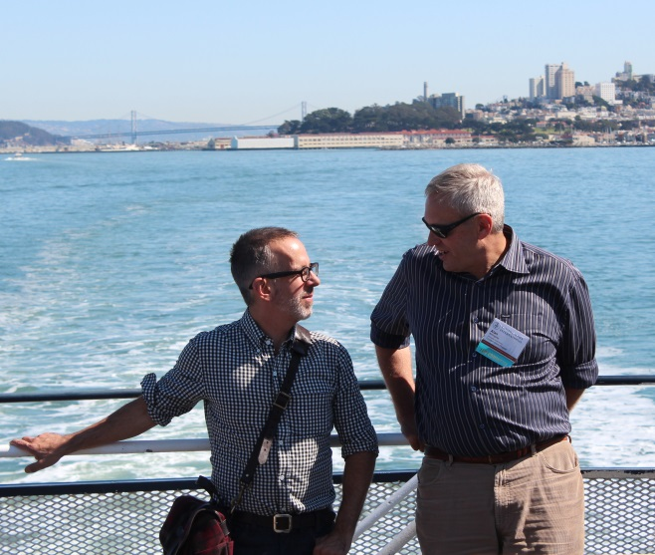
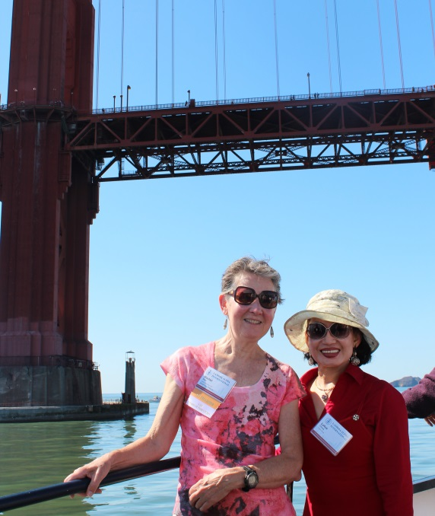
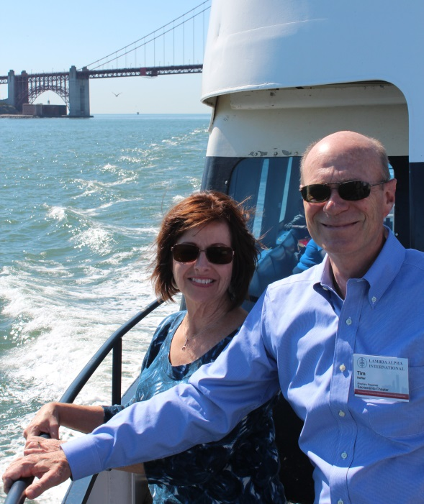

Tour of the Exploratorium
Stepping off the ferry, LAI members set out on a walk down the Embarcadero promenade to the Exploratorium, San Francisco’s beloved science and education center. Our group was welcomed by Rick Feldman, an Associate Principal with the building’s design firm, EDHH; James Suh, partner with KASA Partners, the real-estate company that manages the site’s 9-acre campus; and Tara Ogle, a key role player in the Exploratorium's development.
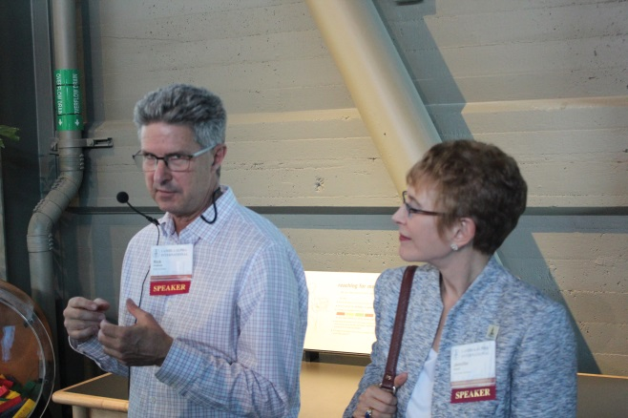
Rick Feldman leading the Exploratorium tour
Feldman explained that the Exploratorium’s role is first and foremost a teaching center. It uses artistic and interactive exhibits to teach patrons about various scientific concepts. Feldman then explained why the Exploratorium moved from its old location next to the Palace of Arts. The Museum had grown out of its previous building and the waterfront offered more accessibility to the majority of the Bay Area’s residents. In what was now a well-established theme of the weekend, Feldman discussed how sustainable design was a crucial component in this project. The Exploratorium is a net-zero energy building, producing as much energy as it uses. This was achieved by a number of strategies. Museum exhibits were changed to be more energy efficient. An ocean water heating and cooling system is used to regulate the museum’s internal temperature. Electricity for the building is generated by the approximately 6,000 solar panels on its roof.
Next, James Suh, the leading developer spoke to LAI members about the hurdles of getting a project of this scope off the ground. With a price tag of over $220 million, developers needed to think creatively for financing strategies. Rent credits acting much like a loan were used to help put the project over its hump.
LAI members were next given a tour of the museum. Everyone was given a portable radio receiver and headset, so they could tune in to the tour guide amid the noisy environment of the exhibit spaces. To deal with this chaotic environment, the design strategy involved 3 distinct buildings built within the museum that could control and divide the space well. The rest of the museum is an open warehouse. Upon exiting our conference room it became clear why such strong boundaries in the museum were needed. The air was immediately filled with the children’s laughter and clatter of running feet from the exhibit space below. “This is the most fun place to work in the world.” said Feldman grinning as he plugged in his radio transmitter.
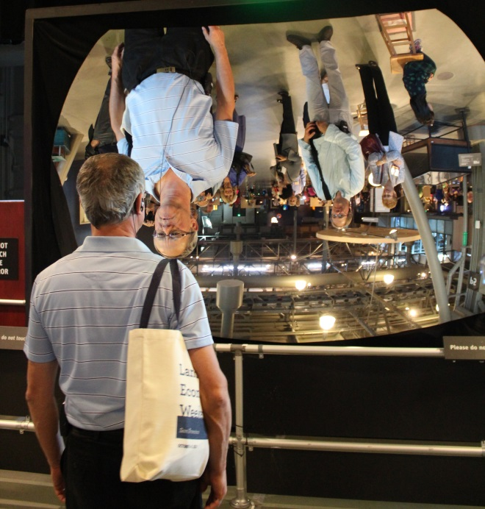
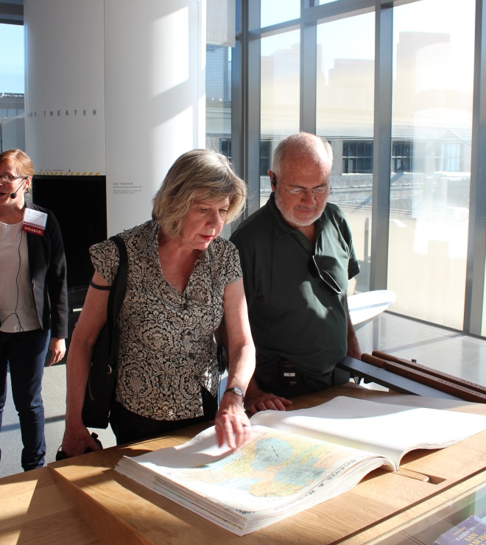
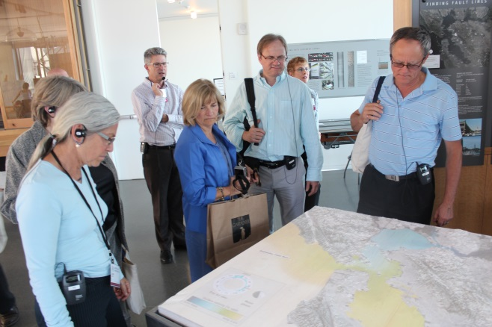
Dinner Gala
The Land Economics Weekend drew to a close with a gala and awards dinner at the University Club on top of Nob Hill. Trolley cars were provided to whisk LAI members up to the historic hilltop social club.
List of Award Honorees
Richard T. Ely Distinguished Educator Award: Grandy Gammage (accepted by Sheila Harris on behalf of Grandy Gammage)
International Journalism Award: John King
International Urban Affairs Award: Stanley Kwok
International Member of Year: Lynn Sedway
International Public Official Award: Jesse Smith
International Skyline Award: Waterfront Toronto (accepted by Robert McBride on behalf of Waterfront Toronto)
Jim Fawcett and Les Pollock became LAI Fellows at the Gala.
The night’s ceremonies ended with Tim Youmans being sworn in as Lambda Alpha International’s next President.

